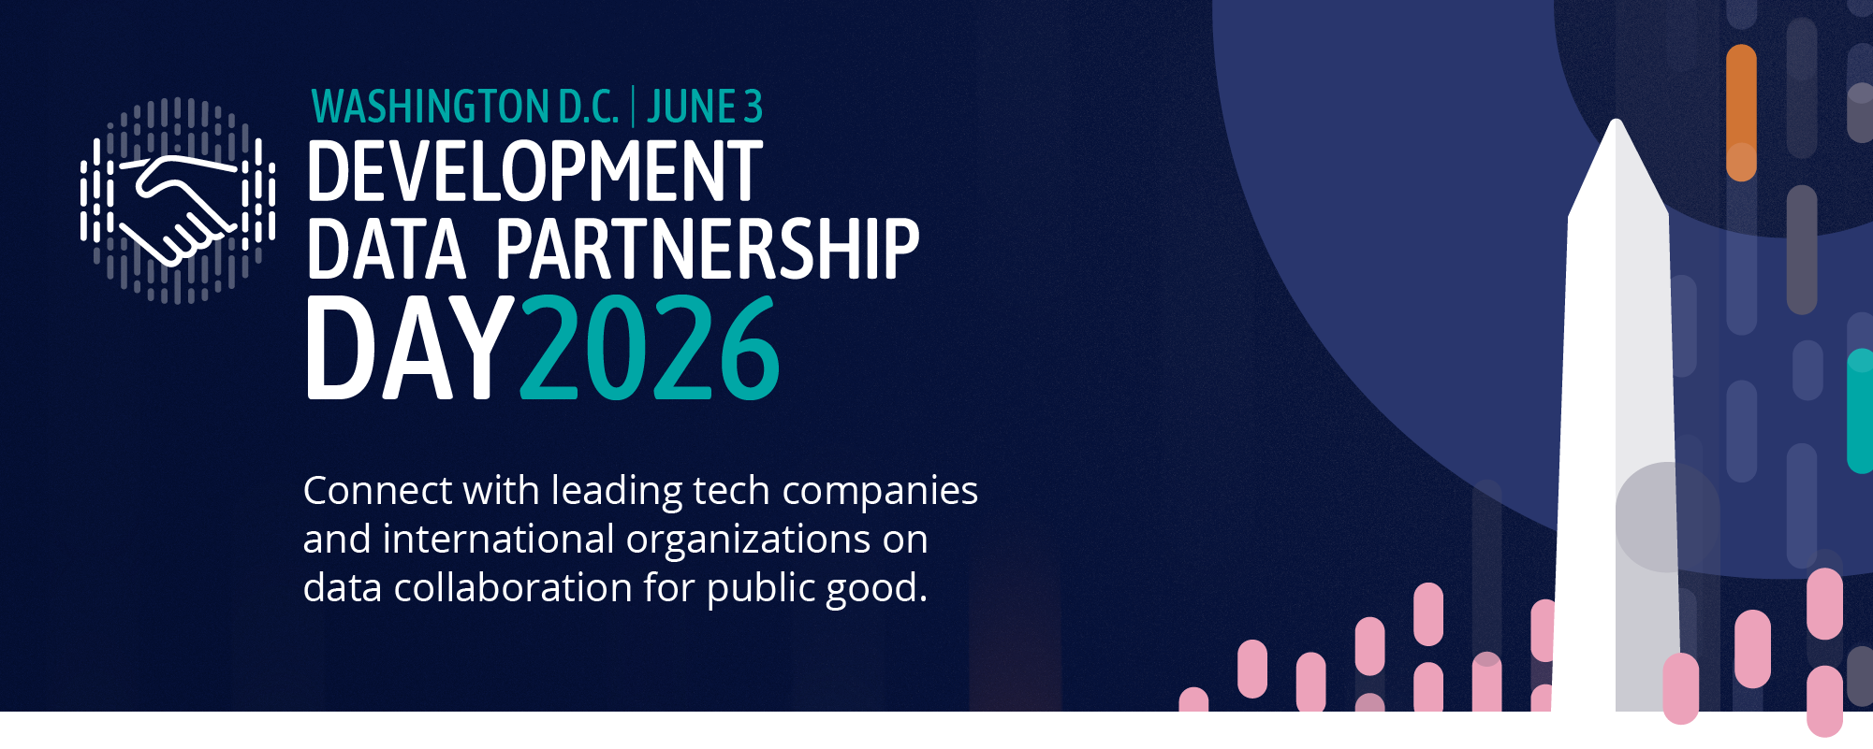

DEVELOPMENT DATA PARTNERSHIP DAY

Time | Topic | Lead
8:30 | Registration
9:00 | Opening Remarks
9:05 | Keynote: What Public-Private AI Partnerships Are Delivering — and Where They're Headed | Aisha Walcott-Bryant, Head of Google Research Africa
9:25 | State of the Partnership | Holly Krambeck, Program Manager, World Bank
9:35 | How AI is Reshaping Labor Markets: Findings from International Organizations Working with LinkedIn Data  Economists from the OECD, IMF, World Bank, and CAF share what LinkedIn's global data is revealing about how AI is reshaping skills, hiring, and labor markets — moderated by LinkedIn | Casey Weston, Senior Manager, LinkedIn (Moderator)  ---  El Iza Mohamedou, Head of the OECD Centre for Skills, OECD  Cheryl Li, Research Analyst, IMF  Sahiti Sarva, Data Scientist, World Bank Group
10:25 | Impact Stories  Fast-paced relay-style presentations, jointly given by the tech company and the international organization staff who worked together to create impact. | Connecting Guatemala's Schools to the Internet  Enrique Iglesias Rodriguez, Telecomunication Sector Specialist, Inter-American Development Bank  Katherine Macdonald, Senior Director, Ookla for Good & Strategic Initiatives, Ookla  Advancing Low Emission Zones in Southeast Asia  Sebastian Muller, Technical Lead, Data & AI  Asian Development Bank
11:00 | Break
11:15 | AI's Impact on Work and the Economy: Research from the Companies Building the Technology  Researchers from Anthropic, OpenAI, Microsoft, and Google share what their in-housework is revealing about AI's effects on jobs, productivity, and economic opportunity — in conversation with the World Bank Group Chief Economist | Indermit Gill, Chief Economist, World Bank Group World Bank (Moderator)  ---  Ruth Appel, Economics Program Manager, Anthropic  Rachel Brown, Data Scientist, OpenAI  Seth Spielman, Director, Microsoft AI  Michael Pisa, Economic Opportunity Lead, Google
12:15 | Impact Stories  Fast-paced relay-style presentations, jointly given by the tech company and the international organization staff who worked together to create impact. | Integrating Flood Risk with High-resolution Wealth Mapping in Asia and the Pacific  Takaaki Masaki, Senior Economist, Asian Development Bank  Mapping Human Displacement in Sub-Saharan Africa Using Nighttime Lights  Mohamed Ali Hadj Taieb, African Development Bank
12:50 | Closing Remarks
1:00 | Close

STRATEGIC ADVISORY GROUP MEETING
Wednesday, June 3, 2025
World Bank Group, MC 13-121 (1818 H Street NW, Washington, DC, 20433)

Time | Topic
13:00 | Lunch
14:00 | Strategic Goals Report
14:15 | Special Projects Update:  - Code Catalog  - Low-Resource Language Datasets  - Global AI Index
14:45 | Discussion: Crisis Data Package
16:00 | Discussion: Strategic Goals and Planning for the Year Ahead
16:50 | Closing Remarks
17:00 | Social Gathering at the IMF

DATA AND DEVELOPMENT PARTNER MEETINGS
Thursday, June 4, 2026
Inter-American Development Bank Headquarters
1300 New York Avenue NW, Washington, D.C. 20005

Time | Topic
8:30 | Registration
9:00 | Opening Remarks
9:10 | Bilateral Data Partner and Development Partners Meetings
2:00 | Field Trip: OpenAI Office

DDP TRAINING DAY
Friday, June 5, 2026
World Bank Group (1818 H Street NW, Washington, DC, 20433)

 | TRANSPORTATION TRACK | JOBS & ECONOMY TRACK | GEOSPATIAL TRACK
9:00 |  | Anthropic: Work with Anthropic Economic Index Datasets to Generate Insights on Adoption and Use of Claude.ai  Ruth Appel, Anthropic
9:30 | Grab and MapBox: Visualize Congestion with Traffic Data with Code Packages  tbc, MapBox  Maria Sol Tadeo, World Bank  Sebastian Mueller, Asian Development Bank |  | ESRI: Getting the Most Out of Living Atlas and ESRI Tools for Python and R Users (virtual) (Part I)  Robert Rike, ESRI  Daeun Kang, IDB
10:00 |  | Google Trends: Nowcasting GDP with Search Data  tbc, Google  tbc, IMF
10:30
11:00 | Waze: Build Map of Traffic Jams and Road Incidents using Code Packages  tbc, Waze  Maria Sol Tadeo, World Bank | Ookla: Map the World’s Internet Connectivity  Niccolo Comini, World Bank  Mykhailo Koltsov, World Bank  James Carroll, Ookla
11:30
12:00 | Lunch | Lunch | Lunch
12:30
13:00 | Irys and Quadrant: Use Mobile Location Data to Measure Population Movement and Activity Level Trends  Sebastian Mueller, Asian Development Bank  Maria Sol Tadeo, World Bank | OpenAI: Work with OpenSignals Data to Understand How People Use ChatGPT  Alex Martin Richmond, OpenAI | ESRI: Getting the Most Out of Living Atlas and ESRI Tools for Python and R Users (Part II)  Robert Rike, ESRI  Daeun Kang, IDB
13:30 |  | LinkedIn and GitHub: Learn to Use Economic and Innovation Graph Data to Measure Labor Trends  Rosie Hood (tbc), LinkedIn  tbc, GitHub  tbc, World Bank Group
14:00
14:30

